

Projekt

PPJ

Andrii Kovalchuk

S11847

# About project

## Topic of project

That Android application helps teachers to organize the groups of students in university, put subjects and teachers, get the ranking list of marks.

## Motivation

To help teachers and administration in organizing the base of educational process. Moreover, the main point – to help them “from pocket”. It mean that you can ride on a train and organize the groups of students and you even do not need any laptop, because you Android smartphone is always with you.

## Future of the project

VUnivesity is absolutely free and open source project. In addition, I will try to put it into Google Play.

GitHub profile: <https://github.com/a9595>

GitHub link to project: <https://github.com/a9595/Vuniversity2>

# Solution description

## Technology

VUnivesity is based on Android 2.1 and higher. Therefore, besides innovative Android smartphones, you can use VUnivesity even at old devices (eReaders based on Android for example).

Database core of VUnivesity based on SQLite. SQLite is energy efficient and resources efficient database.

## IDE

Eclipse ADT. And Genymotion for virtual testing of VUnivesity

## Libraries

Android 2.1 only. I have not use any additional library because of resources efficiency.

# User interface

## C:\Users\Andriy\AppData\Local\Temp\tmd_iu_temp\iu_temp_a1234d48\screenshot 2014-01-24 001.pngOrganize student groups

“Groups” 🡪 “Add new” 🡪 Put name of group 🡪 Tap on your group 🡪 “Add new” 🡪 Fill all fields 🡪 press “Create new”

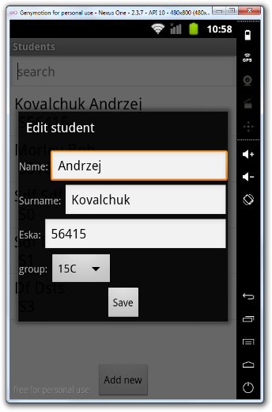

## Edit Student

Long tap on student 🡪 Edit what you need 🡪 “Save”

## C:\Users\Andriy\AppData\Local\Temp\tmd_iu_temp\iu_temp_a1234d48\screenshot 2014-01-24 003.pngSort students

Press menu button on your smartphone 🡪 Select sort type (sort by surname abc for example)

## Add new subject

In main menu press “Subjects” 🡪 “Add new” 🡪 “Create new”

## Remove subject

Long press on subject 🡪 Remove

## C:\Users\Andriy\AppData\Local\Temp\tmd_iu_temp\iu_temp_a1234d48\screenshot 2014-01-24 004.pngAdd subject for teacher

Long press on teacher (from Teachers menu) 🡪 “Edit” 🡪 “Add subject” 🡪 “Add”

## C:\Users\Andriy\AppData\Local\Temp\tmd_iu_temp\iu_temp_a1234d48\screenshot 2014-01-24 005.pngPut mark for student

On student menu, long press on student 🡪 “Put mark” 🡪 Select subject and mark 🡪 “Put mark”

## C:\Users\Andriy\AppData\Local\Temp\tmd_iu_temp\iu_temp_a1234d48\screenshot 2014-01-24 006.pngShow marks rating

On main menu, “Marks” 🡪 Choose subject

# C:\Users\Andriy\AppData\Local\Temp\tmd_iu_temp\iu_temp_a1234d48\screenshot 2014-01-24 008.pngCode description

## Main classes

### Student

Describes student model

### Teacher

Describes teacher model

### Group

Describes group model

### C:\Users\Andriy\AppData\Local\Temp\tmd_iu_temp\iu_temp_a1234d48\screenshot 2014-01-24 007.pngStudentsActivity

Let you to show Android activity of students

### C:\Users\Andriy\AppData\Local\Temp\tmd_iu_temp\iu_temp_a1234d48\screenshot 2014-01-24 009.pngAddTeacherActivity

Let you to add new teacher

### C:\Users\Andriy\AppData\Local\Temp\tmd_iu_temp\iu_temp_a1234d48\screenshot 2014-01-24 010.pngEditSubjectActivity

For editing a subject

### C:\Users\Andriy\AppData\Local\Temp\tmd_iu_temp\iu_temp_a1234d48\screenshot 2014-01-24 012.pngC:\Users\Andriy\AppData\Local\Temp\tmd_iu_temp\iu_temp_a1234d48\screenshot 2014-01-24 011.pngDatabaseHelper

Helps to connect to database

### TestAdapter

Contain all methods for getting\setting\editing data in our database

## Application lifecycle

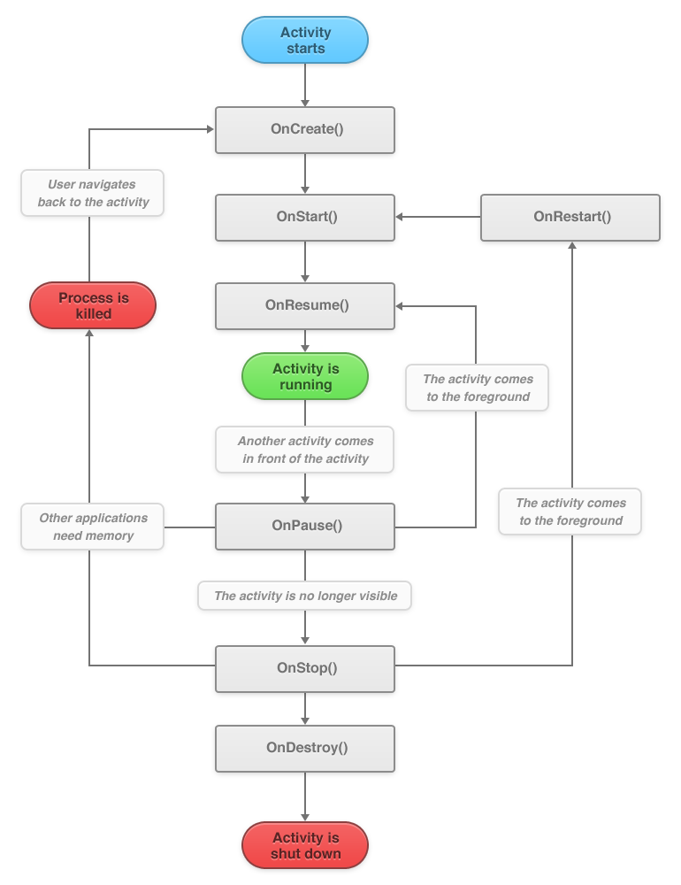

## Error handling

1. Duplicates handling – on SQLite level. Made by selects
2. Empty fields handling – you have error message if fields is empty